EWMA correlation: GBPUSD and AUDUSD
Method 06 / daily log returns / lambda = 0.94 / Alpari D1 full available history

Study setup
Logical pair: GBPUSD , AUDUSD
Broker symbols: GBPUSD_i , AUDUSD_i
Snapshot: 2026-11-03_majors_alpari_D1
Timeframe: D1
Matched return window: 1999-01-05 to 2026-11-02 (UTC bar dates)
Matched return count n: 7228
Dropped unfinished last bar dated 2026-11-03 UTC after a tick-volume check against the prior complete day.
Lambda: 0.94 (today weight 0.06)
Burn-in ignored in path summaries and chart: first 60 updates
Mean adjustment: each leg demeaned by its mean on the matched rows
Seeds: c_0 = v_x,0 = v_y,0 = 0
Complete matched rows (Excel): GBPUSD-AUDUSD_EWMA_D1.xlsx
Complete matched rows (HTML table): GBPUSD-AUDUSD_EWMA_D1_data.html

Method carried forward
EWMA correlation updates covariance and variances of mean-adjusted daily log returns of close, ln(close_t / close_t-1), with lambda = 0.94 (6% weight on today's product or square, 94% on yesterday's EWMA state). Quotes are not inverted. Each leg is demeaned by its mean on the matched rows; that mean uses the full sample, so the rho path is a full-sample description, not a live filter. Seeds start at zero. Path summaries and the chart ignore the first 60 updates so the zero seed has faded. The headline is rho on the last day. rho is symmetric under swap of the two symbols. A high |rho| does not prove cause, lead-lag, or a trading signal. Today's return sits inside today's rho, so the estimate can only inform a later decision. Same-sample Pearson r is a side check only.

Results
Latest EWMA rho: 0.192217
Post-burn-in path (n=7168): mean=0.517038, median=0.556361, min=-0.272466, max=0.914120, std=0.219776
Share of post-burn-in days with |rho| >= 0.4: 71.93%; |rho| >= 0.7: 23.20%
Same-sample Pearson r: 0.539048
Latest rho minus r: -0.346831

Conclusion
Over 7228 matched daily log-return rows for GBPUSD and AUDUSD (broker quote directions unchanged), latest EWMA rho with lambda=0.94 is 0.1922 (positive, weak recent linear link in this sample). After a 60-day burn-in, path mean is 0.5170, std is 0.2198, and the range is [-0.2725, 0.9141]. Same-sample Pearson r is 0.5390 (latest rho minus r = -0.3468). This does not establish cause, lead-lag, or a lasting trading rule.

Charts
Daily closes

Daily log returns
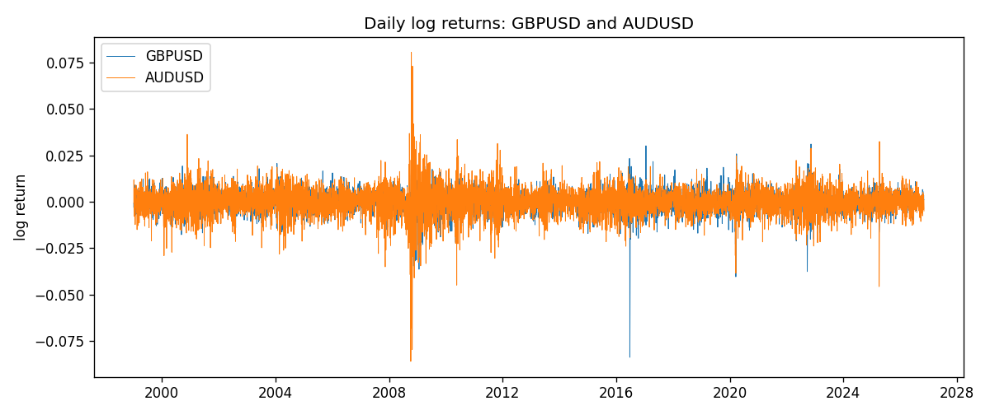
EWMA rho path with Pearson r reference
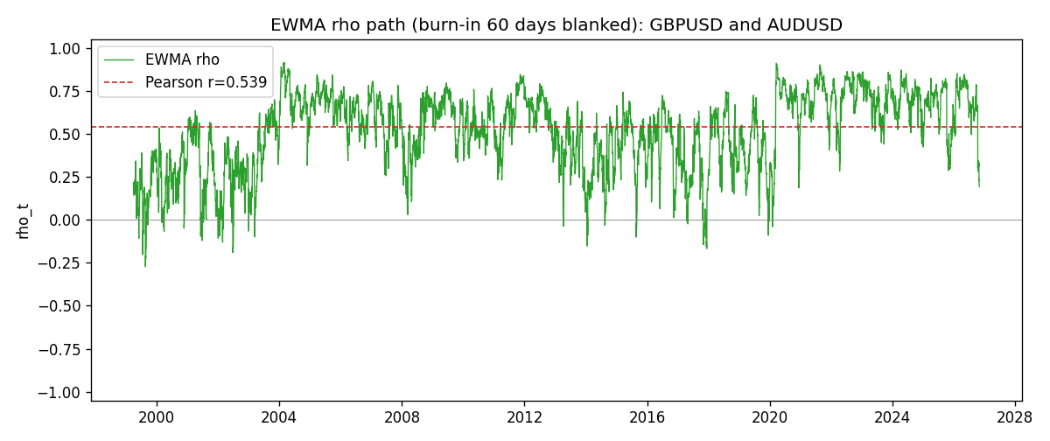

Data report
Every matched row that entered the EWMA recursion is stored in the sibling Excel workbook named GBPUSD-AUDUSD_EWMA_D1.xlsx. That file is the complete data archive for redrawing charts. Embedding all rows as a Word table is impractical at this length; the Word file holds the column list, column summaries, and the first and last 15 matched rows.
Columns: time, GBPUSD_open, AUDUSD_open, GBPUSD_high, AUDUSD_high, GBPUSD_low, AUDUSD_low, GBPUSD_close, AUDUSD_close, GBPUSD_tick_volume, AUDUSD_tick_volume, GBPUSD_spread, AUDUSD_spread, GBPUSD_real_volume, AUDUSD_real_volume, GBPUSD_log_return, AUDUSD_log_return, GBPUSD_x_demeaned, AUDUSD_y_demeaned, c_t, v_x, v_y, rho_t
Column summaries (matched calculation rows)
column | count | mean | std | min | 25% | 50% | 75% | max
GBPUSD_open | 7228 | 1.5166822 | 0.21834818 | 1.06854 | 1.3254025 | 1.51196 | 1.63237 | 2.1066
AUDUSD_open | 7228 | 0.75192541 | 0.13534725 | 0.4785 | 0.66102 | 0.7315 | 0.8091975 | 1.10284
GBPUSD_high | 7228 | 1.5229801 | 0.21891417 | 1.08366 | 1.3300275 | 1.518725 | 1.638825 | 2.1161
AUDUSD_high | 7228 | 0.75597511 | 0.13590934 | 0.4878 | 0.664695 | 0.734945 | 0.81552 | 1.10795
GBPUSD_low | 7228 | 1.5103473 | 0.21757706 | 1.03518 | 1.32009 | 1.50469 | 1.624985 | 2.0983
AUDUSD_low | 7228 | 0.74786335 | 0.13465689 | 0.4775 | 0.6577 | 0.72762 | 0.804475 | 1.0975
GBPUSD_close | 7228 | 1.5167386 | 0.2183035 | 1.06879 | 1.32568 | 1.51203 | 1.6324775 | 2.1065
AUDUSD_close | 7228 | 0.75196864 | 0.13532707 | 0.4786 | 0.6611875 | 0.731775 | 0.809315 | 1.10169
GBPUSD_tick_volume | 7228 | 94565.268 | 153330.81 | 62 | 9974.5 | 52775.5 | 91622.5 | 1273370
AUDUSD_tick_volume | 7228 | 77126.179 | 137934.11 | 109 | 5406 | 43250.5 | 71246.75 | 1234623
GBPUSD_spread | 7228 | 27.003182 | 19.183813 | 0 | 11 | 20 | 50 | 50
AUDUSD_spread | 7228 | 30.855562 | 16.875394 | 0 | 13 | 30 | 50 | 50
GBPUSD_real_volume | 7228 | 3.5428062e+09 | 8.4280615e+10 | 0 | 0 | 0 | 0 | 2.4038164e+12
AUDUSD_real_volume | 7228 | 5.2225089e+09 | 1.2514647e+11 | 0 | 0 | 0 | 0 | 3.811512e+12
GBPUSD_log_return | 7228 | -2.954e-05 | 0.0056473 | -0.08388241 | -0.00313242 | 3.002e-05 | 0.00317333 | 0.03112653
AUDUSD_log_return | 7228 | 1.629e-05 | 0.00754363 | -0.08602525 | -0.00386494 | 0.00027649 | 0.00415111 | 0.0806166
GBPUSD_x_demeaned | 7228 | 0 | 0.0056473 | -0.08385287 | -0.00310288 | 5.957e-05 | 0.00320287 | 0.03115607
AUDUSD_y_demeaned | 7228 | 0 | 0.00754363 | -0.08604154 | -0.00388123 | 0.00026021 | 0.00413482 | 0.08060031
c_t | 7228 | 2.296e-05 | 3.477e-05 | -9.52e-06 | 8.42e-06 | 1.557e-05 | 2.396e-05 | 0.00053036
v_x | 7228 | 3.187e-05 | 3.426e-05 | 4.8e-07 | 1.748e-05 | 2.385e-05 | 3.338e-05 | 0.00052539
v_y | 7228 | 5.687e-05 | 9.998e-05 | 4e-08 | 2.626e-05 | 3.684e-05 | 5.898e-05 | 0.001733
rho_t | 7228 | 0.51112576 | 0.22974795 | -0.65548059 | 0.36295836 | 0.5540362 | 0.6909236 | 1
First 15 matched rows (selected columns)
time | GBPUSD_close | AUDUSD_close | GBPUSD_log_return | AUDUSD_log_return | GBPUSD_x_demeaned | AUDUSD_y_demeaned | c_t | v_x | v_y | rho_t
1999-01-05 | 1.6547 | 0.6215 | -0.0028966287 | -0.00080418179 | -0.0028670862 | -0.00082046926 | 1.4114137e-07 | 4.93211e-07 | 4.0390189e-08 | 1
1999-01-06 | 1.6537 | 0.6289 | -0.00060452184 | 0.011836351 | -0.0005749794 | 0.011820063 | -2.7510468e-07 | 4.8345442e-07 | 8.4208003e-06 | -0.13634635
1999-01-07 | 1.6502 | 0.6345 | -0.002118709 | 0.0088650256 | -0.0020891665 | 0.0088487381 | -1.3677877e-06 | 7.1632417e-07 | 1.2613562e-05 | -0.45503521
1999-01-08 | 1.6405 | 0.6347 | -0.0058954193 | 0.00031515916 | -0.0058658768 | 0.00029887168 | -1.3909091e-06 | 2.7378554e-06 | 1.1862108e-05 | -0.24406896
1999-01-11 | 1.6312 | 0.6393 | -0.0056851331 | 0.0072213815 | -0.0056555907 | 0.007205094 | -3.7523983e-06 | 4.4927264e-06 | 1.4265184e-05 | -0.4687219
1999-01-12 | 1.6349 | 0.6362 | 0.0022657001 | -0.0048608485 | 0.0022952426 | -0.0048771359 | -4.198907e-06 | 4.5392511e-06 | 1.4836461e-05 | -0.51165709
1999-01-13 | 1.6499 | 0.6312 | 0.0091330396 | -0.0078902098 | 0.0091625821 | -0.0079064973 | -8.2936084e-06 | 9.3040707e-06 | 1.7697035e-05 | -0.64633365
1999-01-14 | 1.6531 | 0.6295 | 0.0019376331 | -0.002696916 | 0.0019671755 | -0.0027132035 | -8.1162327e-06 | 8.9780132e-06 | 1.7076901e-05 | -0.65548059
1999-01-15 | 1.6502 | 0.634 | -0.0017558204 | 0.007123101 | -0.0017262779 | 0.0071068135 | -8.3653589e-06 | 8.6181345e-06 | 1.9082695e-05 | -0.65231609
1999-01-18 | 1.6522 | 0.6346 | 0.0012112405 | 0.00094592471 | 0.0012407829 | 0.00092963724 | -7.7942287e-06 | 8.193419e-06 | 1.7989587e-05 | -0.64199252
1999-01-19 | 1.6553 | 0.6392 | 0.0018745281 | 0.0072225153 | 0.0019040706 | 0.0072062278 | -6.503305e-06 | 7.9193429e-06 | 2.0025995e-05 | -0.51640745
1999-01-20 | 1.6472 | 0.64 | -0.0049053846 | 0.0012507819 | -0.0048758421 | 0.0012344944 | -6.4742586e-06 | 8.8706125e-06 | 1.8915874e-05 | -0.49980436
1999-01-21 | 1.6524 | 0.6405 | 0.0031518998 | 0.00078094498 | 0.0031814423 | 0.00076465751 | -5.9398403e-06 | 8.9456703e-06 | 1.7816003e-05 | -0.47050385
1999-01-22 | 1.6565 | 0.6327 | 0.0024781662 | -0.012252745 | 0.0025077087 | -0.012269033 | -7.4294795e-06 | 8.7862462e-06 | 2.5778793e-05 | -0.49365713
1999-01-25 | 1.6585 | 0.6302 | 0.0012066366 | -0.0039591468 | 0.0012361791 | -0.0039754343 | -7.2785716e-06 | 8.3507598e-06 | 2.518031e-05 | -0.50194095
Last 15 matched rows (selected columns)
time | GBPUSD_close | AUDUSD_close | GBPUSD_log_return | AUDUSD_log_return | GBPUSD_x_demeaned | AUDUSD_y_demeaned | c_t | v_x | v_y | rho_t
2026-10-13 | 1.32534 | 0.69821 | 0.0036434319 | 0.0035007712 | 0.0036729743 | 0.0034844837 | 7.6953093e-06 | 9.4648364e-06 | 1.4126803e-05 | 0.66549926
2026-10-14 | 1.31884 | 0.69715 | -0.0049164679 | -0.0015193215 | -0.0048869255 | -0.0015356089 | 7.6838551e-06 | 1.0329869e-05 | 1.3420681e-05 | 0.65259613
2026-10-15 | 1.32757 | 0.69191 | 0.0065976411 | -0.0075447063 | 0.0066271835 | -0.0075609938 | 4.2163382e-06 | 1.234525e-05 | 1.6045557e-05 | 0.29957674
2026-10-16 | 1.33257 | 0.69426 | 0.0037592051 | 0.0033906408 | 0.0037887475 | 0.0033743533 | 4.7304323e-06 | 1.2465812e-05 | 1.5766e-05 | 0.33742697
2026-10-19 | 1.33024 | 0.6978 | -0.0017500314 | 0.0050859986 | -0.001720489 | 0.0050697112 | 3.9232634e-06 | 1.1895468e-05 | 1.6362158e-05 | 0.28121366
2026-10-20 | 1.3377 | 0.70022 | 0.0055923442 | 0.0034620426 | 0.0056218867 | 0.0034457552 | 4.8501663e-06 | 1.3078076e-05 | 1.6092822e-05 | 0.3343248
2026-10-21 | 1.33937 | 0.70275 | 0.0012476328 | 0.0036066384 | 0.0012771753 | 0.0035903509 | 4.8342868e-06 | 1.2391262e-05 | 1.590069e-05 | 0.34440278
2026-10-22 | 1.33967 | 0.70186 | 0.00022396082 | -0.0012672558 | 0.00025350326 | -0.0012835433 | 4.5247066e-06 | 1.1651643e-05 | 1.5045498e-05 | 0.34173823
2026-10-23 | 1.33684 | 0.70353 | -0.0021146949 | 0.0023765656 | -0.0020851525 | 0.0023602782 | 3.9579318e-06 | 1.1213416e-05 | 1.4477023e-05 | 0.31064168
2026-10-26 | 1.33359 | 0.70128 | -0.0024340661 | -0.0032032829 | -0.0024045237 | -0.0032195704 | 4.1849479e-06 | 1.0887515e-05 | 1.4230339e-05 | 0.33621575
2026-10-27 | 1.33044 | 0.70245 | -0.0023648393 | 0.0016669876 | -0.0023352969 | 0.0016507002 | 3.7025585e-06 | 1.0561481e-05 | 1.3540007e-05 | 0.30962076
2026-10-28 | 1.33254 | 0.70533 | 0.0015771808 | 0.0040915541 | 0.0016067232 | 0.0040752666 | 3.8732746e-06 | 1.0082685e-05 | 1.3724075e-05 | 0.32926733
2026-10-29 | 1.33733 | 0.70245 | 0.0035881935 | -0.0040915541 | 0.003617736 | -0.0041078416 | 2.7492129e-06 | 1.0263005e-05 | 1.3913092e-05 | 0.23006962
2026-10-30 | 1.33913 | 0.70316 | 0.0013450605 | 0.0010102376 | 0.0013746029 | 0.00099395016 | 2.6662373e-06 | 9.7605967e-06 | 1.3137583e-05 | 0.23545227
2026-11-02 | 1.3406 | 0.69971 | 0.0010971256 | -0.0049184984 | 0.001126668 | -0.0049347859 | 2.1726712e-06 | 9.2511237e-06 | 1.3810455e-05 | 0.19221743

